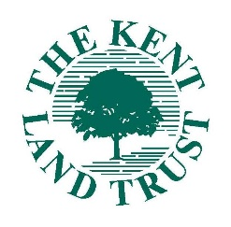
Kent Land Trust 2018 Exploration Challenge
Image Consent and Release

Please fill in your Team Name and complete the Image Consent and Release below to give KLT permission to use submitted photos. After signature, this form may be scanned and submitted to KLT electronically.

Team Name: _______________________________________________________

Kent Land Trust 2018 Exploration Challenge Image Consent and Release

I, __________________________________, give the Kent Land Trust permission to use my name and my image as embodied in any photographs submitted in association with the Kent Land Trust 2018 Exploration Challenge. I agree that the Kent Land Trust has ownership of such images and may use them for any purpose consistent with the mission of the Kent Land Trust and in any medium, including but not limited to any print medium, the Kent Land Trust website, social media platforms, and any other on-line medium. I acknowledge that I will not receive any compensation for the use of such pictures and I hereby release the Kent Land Trust and its agents and assigns from any and all claims which arise out of or are in any way connected with such use.

I have read and understood this Image Consent and Release and hereby give my consent to the Kent Land Trust.

Adults (age 18 and above):

Printed Name: _____________________________________________

_______________________________________________ __________________
Signature Date

Minors:

Printed Name of Minor: __________________________________________

Printed Name of Parent/Guardian: ________________________________________

_______________________________________________ __________________
Parent/Guardian Signature Date

